SDV 100-083A: Week 2 – Assignment:College Policies and Services

July 30, 2012

Casey Carnnia #6318480

Student

Northern Virginia Community College – Alexandria Campus

Please review the following links and submit a document listing at least two things you learned from each.

http://www.nvcc.edu/current-students/policies--forms/student-handbook/

Student Handbook

*Tuition refund*

A student can pick up a class and then drop it. But if one enrolls in a class and then abandon it he/she cannot count on automatic tuition refund process. The only time that tuition is automatically refunded is when the school cancels a class.

*Parking Permits*

I looked around the campus parking lot for an answer to this question but I found the answer here. I had assumed that maybe parking at the metered lot would be free after a certain time, as it is in the city. But I learned here that “Parking regulations are enforceable 24 hours per day, seven days per week”.

http://www.nvcc.edu/academics/academic-calendar/index.html#fa11

Academic Calendar

*Census Date*

This is an important date to remember. This is the last date to drop a class and receive a tuition refund. Even if you were willing to pay the tuition there is no way to eliminate the class from your academic record after this point

*Priority Date*

Thing like financial aid and graduation have a “Priority” date assigned to them but this does not mean that earlier dates are unavailable. So prior to the date mentioned on the academic calendar for graduation one can submit the application.

http://www.nvcc.edu/depts/academic/proginfo.htm

Program Advising Sheets

*Advising Sheet*

It lists all the courses required for graduation in a particular program. This is what I am using as a base for a plan to then build of with the help of an advisor. The required classes and their prerequisite work as a skeleton and the electives can help make the degree more personal. *Print/File*

I understand that as time goes the school may change the plans as to what is required to obtain a particular degree. But these changes are not retroactive.

http://www.nvcc.edu/current-students/transfer/transferadmissions/index.html

Transfer Admissions Information

*George Mason University*

GMU does have a transfer program which recognizes credits earned at NOVA toward B.S. in Computer Science. But Volgenau School of Engineering is competitive and a gpa of 3.0 will be required by 2013.

*Recommended Program*

Recommended program for transferring to GMU is:

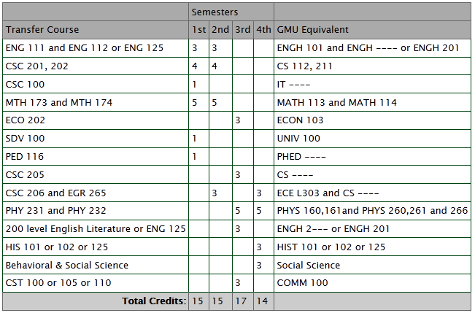

http://www.nvcc.edu/current-students/paying-for-college/payment-methods/index.html

Payment Methods and Deadlines

*Payment Plan*

If you have to pay tuitions out right there is a payment plan but it is not free. There is a enrollment fee and down payment maybe required. This service is administered by a third party. (NBS).

*Funds from Student Loan*

The school does not pay the leftover funds directly to the student. The leftover funds come in the form of a check from State of Virginia.

http://www.nvcc.edu/current-students/graduation/index.html

Graduation

*Commencement Ceremony*

There is no fee required and the ceremony is held in May but the cap and gown is provided by the student.

*Requirements*

Simply completing the coursework with at least 2.0 gpa is not enough. Besides meeting the financial obligations an approval from faculty advisor is also needed.

http://www.nvcc.edu/current-students/career-services/students/crdc.html

Career Resource and Development Center

*Internship*

A challenge for students that want to enter the workforce after graduation is job experience. Internship services provided here can be a very good solution.

*C.R.D.C*

Besides the online self –help tools offered, the Annandale Campus also offers career counseling and resume critiques and mock interviews to the students that need it.

http://www.nvcc.edu/current-students/services-to-students/advising--counseling/

Advising and Counseling

*Virtual Advising*

From 11:30 to 2:30during week days and 6:00 to 8:00 during week nights this service is available via chat and emails are answered within 24 hours.

*Pathway*

Pathway to Baccalaureate program is offered to high school seniors to help them with the transition from high school to nova and then to university. This program provides ongoing counseling and student support.